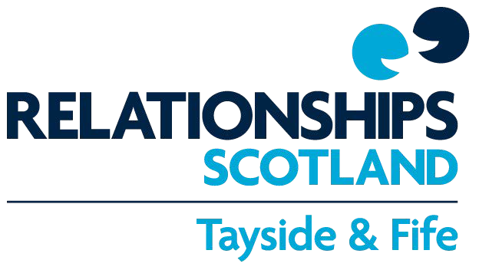

Essential Information - Child Contact Centres

- 15-minute rule: You are given separate arrival and departure times which are 15 minutes apart. You must adhere to these times as closely as possible.
- No recordings please: Video/audio recording within the Contact Centre is not permitted; photos however can be taken (unless a court order is in place prohibiting this).
- Mobiles off please: Those attending the Contact Centre are asked to turn their mobile phones off for the duration of your visit. If you wish to use your mobile to take photographs, please speak to staff.
- No drink, no drugs, no inappropriate language please: If a parent/visitor appears to be under the influence of alcohol or drugs, or any inappropriate behaviour or language is used, the visit may be cancelled or stopped. Any verbal abuse of our staff may result in our services being withdrawn. Smoking is not permitted.
- Safety and welfare: We take the safety and welfare of all attending the Contact Centre very seriously, with particular focus on the child(ren). We may require to contact the appropriate statutory agencies if we have a child protection or welfare concern.
- Positive handling of children: this refers to the use of physical touch such as, to:
  - provide emotional support (placing one’s arm around an upset child for comfort)
  - give guidance (holding the hands of a toddler who is learning to walk, to lead them through for their visit)
  - physical care – supporting and advising parents, only.
We do not physically restrain children unless their safety is in immediate danger.

- Medication: Please ensure that any required medication is taken prior to or after visits. Only essential medication that you or the children must carry at all times, will be permitted in the Centre.
Please note - Contact Centre staff will hand over children’s current, prescribed medication from one party to the other, if necessary. You will be required to sign for receipt and return of said medication on the day.
- Visits by agreement only: All parties are requested to attend the Contact Centre alone, unless something different was previously agreed upon by all parties, including us.
- Contract: All the above will be re-iterated before the first visit and parties will be
asked to sign an agreement to confirm that they have understood these terms.

- Family Support Worker: Our Family Support Worker will contact you to offer you
individual, confidential support.
- Reviews: We review arrangements with you around the 6th visit and then at
regular intervals. A scheduled or upcoming review does not, in itself mean that
visits are stopping.

− Opening hours and telephone numbers for the Centres:
Arbroath Saturdays, 10am to 4pm 07938243223

Dundee Thursdays, 12pm to 7pm

07938243221

 | Saturdays, 10am to 4pm | or on 01382 787772
Glenrothes | Saturdays, 10am to 4pm | 07938243224
Kirkcaldy | Saturdays, 10am to 4pm | 07938243234
Perth | Saturdays, 10 am to 4 pm | 07938243222
Online or face to face supervised visits may be available outwith the above times in Dundee and Glenrothes only, strictly at the discretion of the Service.
The above numbers are only active during the Centres' opening times.

- Cancelling a visit: If you need to cancel a visit for any reason, you must inform the Centre staff as soon as possible. You may contact the Dundee/Glenrothes office if you wish to make a cancellation in advance but for last minute cancellations, please always contact the above mobile, and leave a message if necessary. Please be aware that whilst we endeavour to maintain confidentiality and our neutrality, the Service may be required to disclose the reasons for a visit being cancelled, for example if requested to do so by the court.
- Attendance Record: Generally, the only information we provide about Supported Contact or Facilitated Handovers, is an Attendance Record. This can be requested by either party, or their legal representatives, or the court. There is a charge for this. The Attendance Record is brief and factual. It indicates dates, times and other objective data (e.g. whether a session has been attended/cancelled/not attended; if cancelled the reasons given). No comments as to the quality of visits will be included. Regardless of who requested the report initially, and how the costs are shared, both acting solicitors will receive a copy of the report as soon as it becomes available, providing they have signed our terms of engagement. You may request a copy from them. Where this isn't in place, you can receive a copy directly from us. The Court will also receive a copy.

- Supervised Report: A written report on Supervised Contact may be requested by either party, or their legal representatives, or the court. There is a charge for this. Reports are based on factual information about visits, as observed by the contact supervisor. A Report can contain feedback on several visits, and so they will be a summary account of individual observations. Regardless of who requested the Report initially, and how the costs are shared, both acting solicitors will receive a copy of the report as soon as it becomes available, providing they have signed our Terms of Business. You may request a copy from them. Where this isn't in place, you can receive a copy directly from us. The Court will also receive a copy.
Both documents may include additional information only if it relates to a Health and Safety concern or incident, or a Child Safety/Welfare concern, or an incident that may have arisen while parties and child were engaging with staff.

Additional terms apply for online and indirect sessions.

Please sign below to confirm that you have read, understood and accept the above terms.

Signature...................................................... Date ……………………………………

